
6LR Genuine Parts – Sometimes it pays to stay original!

By: Bill Bettridge

Let me preface this article by saying that normally I am NOT a proponent of buying “Land Rover Genuine” parts, except when necessary. Not to offend, but I’ve always found it somewhat silly to hear people say they will only use “genuine” belt, hoses, spark plugs, brake pads, etc when all those items are provided by the current OEM low bidder, and those same suppliers provide identical non-branded product to the automotive aftermarket.

Anyway, to get on with it – I recently found a case where buying LR Genuine might payoff……..radius arm bushings. In the case of my Disco especially, I expect to replace radius arm bushings fairly often – with almost all off-road use and lots of front end flex, the bushings naturally are not going to last very long. Where on a road-going Rover, you might get 75,000 miles from a set of bushings, I’d expect to get maybe half that in my case. Regardless, last time I purchased bushings, I shopped around and decided that the $5.00 that DAP charged versus the $15.00 that Rovers North charged was too much difference to ignore since I planned to replace them often anyway, so I went ahead an purchased the DAP versions. I received them and they looked OK, but am not certain who manufactured them and went ahead and installed them.

At first they seemed just fine, but after a few trail miles and especially after a switch to a 32” Super Swamper tires (which seek out and magnify any handling problems you may already have), things went south quickly! At first I didn’t even consider the bushings as source of the problem since they were so new and began looking at all kinds of other things – shocks, swivels, brakes,, etc. After fruitless search in those areas, I just ignored the problem until one day after pressure-washing mud off the undercarriage after an event, noticed that the radius arms were pushed completely to the outsides of the axle brackets, instead of centered in the middle. Hmmmm…..this isn’t right said I! So with a little pry bar time, I noticed that the radius arms would easily slide back and forth within their brackets – the only culprit for this is worn-out bushings….dammit.

Here are a few photos of the “DAP” bushings as the arms came off the truck. Not much left of them. In all cases the center sleeve that locates the arms in the brackets is completely loose, and in one case the out sleeve has also become un-bonded. Believe me, you will not like the handling in this condition.

Oh yeah – did I mention that this was after only 6000 miles!?

Funny thing is that I’d expect this with all the useless urethane bushings out on the market that are touted as the greatest thing since sliced bread, since there is no chemical bond of urethane to the steel sleeves, but it is just poor manufacturing to have this occur with a vulcanized rubber bushing.

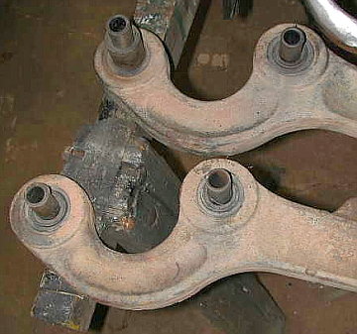

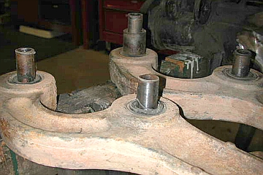

Now lest you think I’m just crying over more maintenance time spent on the truck, I’m not. I don’t mind changing radius arms and have a 25 ton press for bushings and always have an extra set of radius arms ready to swap into the truck. (BTW – much faster than pulling the arms, fighting bushings out/in, and then reinstalling all in a day). BUT, there are certainly other things I’d rather spend 3 hours on than doing that!

So this time I swallowed my pride and called Rovers North for genuine LR bushings. Lets hope that since I got about 50K+ out of the original set that I can get at least 30K out of these.

So, that’s it – just a short lesson on buying “cheap” sometimes

